OPEN CALL
Troja Chateau Landscape
July 18, 2023

The Prague City Gallery announces an open non-anonymous call for projects and realization of temporary artworks, small artistic and architectural works, or performative / research interventions for the Troja Chateau area.

The winning projects can be realized between September 15 and November 30, 2023 according to their type and technical challenges.

TOPICS/PLACES:

- Homage to…
- Haltýř Creek
- Former ford
- Watermill
- Axis of the chateau, way of the bulwark
- Rybáře Village

TARGET AUDIENCE OF THE CALL:

Artists, architects, designers.

TERMS AND CONDITIONS FOR APPLICATIONS:
- Please submit the completed application forms with required attachments until August 24, 2023 (the deadline is midnight) to the following addresses: umenipromesto@ghmp.cz and anna.gumplova@ghmp.cz
- Only one proposal, with the appropriate application form and required attachments, can be submitted per intervention.
- Preferred are documents in PDF or JPG formats, with attachments below 10 MB.

PROPOSAL PARAMETERS:
- Concept proposal / vision of the research / work with the area, object or artwork (text, max. 500 characters).
- Proposal of an art intervention in the print quality (annotation, script, sketch, study, video/audio etc.).

REQUIRED ATTACHMENTS TO THE PROPOSAL:
- Application form
- Budget
- Portfolio with examples of the author’s approach to the public space
CONTEXT OF THE CALL:
We’re building an imaginary bridge between the art in the public space, ephemeral interventions, land art, performative art formats and scientific interpretation of the landscape, using science and humanities. Using various means of interpretation (installations, events, performances, photos, movement, audio, video…), the contemporary art helps people identify with the suburbs and the urban wild.
For the open call for art interventions, the commissions have been prepared related to the cultural landscape formed by the suburban Troja Chateau since the 17th century.

Using various means of interpretation (installations, events, performances, photos, movement, audio, video…), the contemporary art helps people identify with the suburbs and the urban wild.

TERMS AND CONDITIONS:

- The application form must be submitted for each part separately. There can be no more than 3 application forms per participant.
- The essential assessment criteria will be the quality and originality of the artistic intervention.
- All proposals must respect the principles of the open and democratic society.
- The sensitive integration into the surroundings is expected. No part of the project can cause any hazard to the public or transport.

The financial reward (1st, 2nd and 3rd place) will be provided for three of the best proposals for the object interventions (probably Haltýř Creek and Homage to…). The winning project will be realized. Other locations will be assessed individually, and multiple projects of performative nature may be selected for a single area and/or topic.

REWARDS:

For Haltýř Creek and Homage to…, the committee will reward the acclaimed projects as follows:

Reward for the 1st place – 30,000 Czk
Reward for the 2nd place – 20,000 Czk
Reward for the 3rd place – 10,000 Czk

As for performative and art-research interventions, the jury will select at least 5 projects to be realized, and the funding will be based on their respective budgets.

Furthermore, the committee can also give away rewards in the total amount of 30,000 Czk for projects that will not be realized in 2023 but their artistic or inventive qualities are outstanding, as well as their benefit for the location.

TOPICS / AREAS

Haltýř Creek
Vltava in Šumava – Vltava in Prague, every tributary tells a story

History and context:
Vltava comes all the way from Šumava, and every tributary, even a small one, makes it stronger – including the Haltýř Creek. It was used for the fountains in the Troja Chateau, and also for the discontinued public spring in the outer wall.
The current well, or water tank, is located in the central part of the Havránka Valley, above the Prague Botanical Garden, the axis of which is a pathway between the streets K Pazderám and Pod Havránkou. The spring a source of a short but important creek known as Haltýř. Since the middle ages, the spring was source of water for the whole Troja, and also for the Troja Chateau (according to written documents, water was conveyed by a wooden pipeline to the chateau since 1670). This source was also used by the Prague Zoo until the 1980s, when the pipeline was discontinued in the whole chateau garden during the Troja Chateau reconstruction.
Expected is a reminder of the spring in the form of an object artistic intervention, in the alcove of the garden wall (see the map and photo below).
Source: http://www.praha-priroda.cz/vodni-plochy-a-potoky/studanky-abecedne/trojsky-haltyr/

Recommended form of realization:
Temporary artwork or small art-architectural intervention

Map:
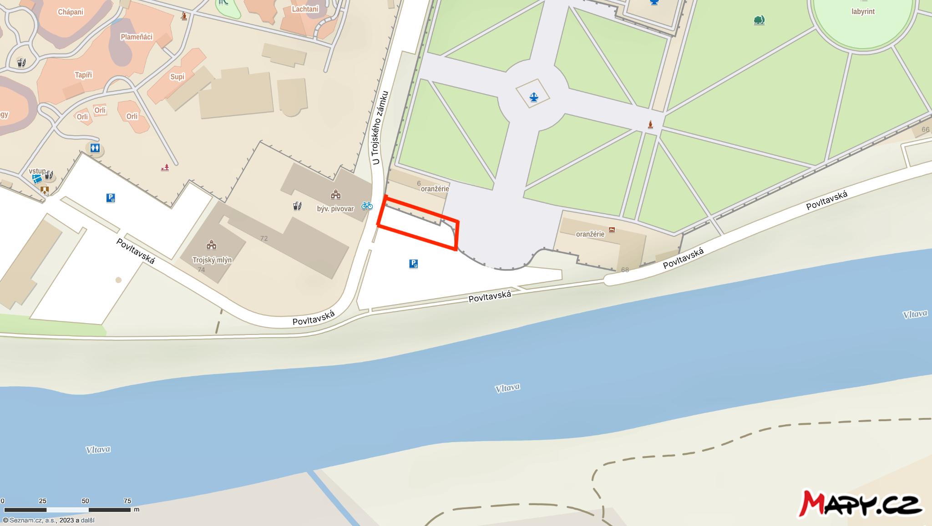

Photos:
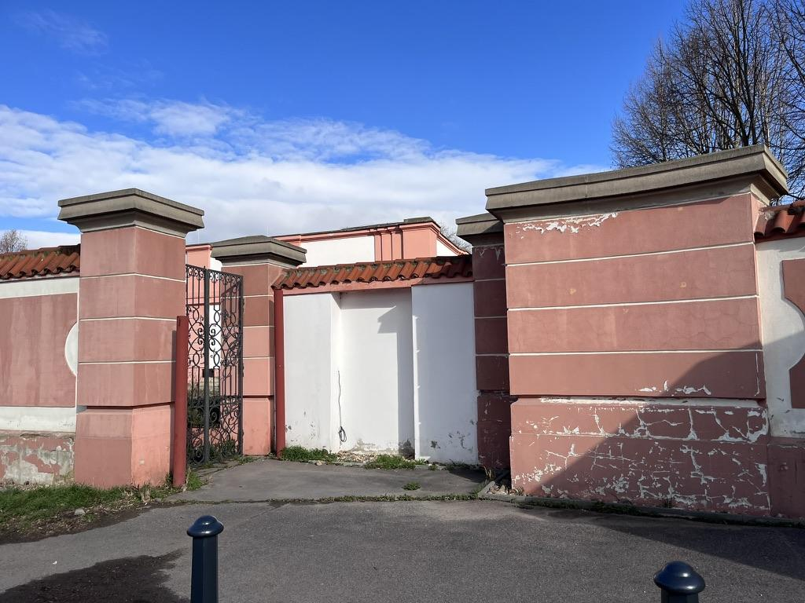

Homage to …

History and context:

The history of the area and its surroundings has always been affected by local celebrities and their families. Originally, this suburban village, independent until 1920, was called Zadní Ovenec. The name Ovenec (Oveneč, Ovence or Owenetz) dates back to the middle ages, probably originating in the name “Ovenec’s Yard”. The village was first documented in 1197, as a property of the Premonstratensian monastery in Teplá. To differentiate the settlements on either bank of the Vltava River, the village on the right bank got the name Zadní or Horní Ovenec (“Upper”) in the 13th century, while the “Lower” one became Bubeneč over the centuries. The new name Troja dates back to the 18th century – the settlement was renamed after the Troja Chateau, built near the river by the Sternberg House together with the garden and barns.
Source: https://www.mctroja.cz/jak-vznikala-troja-1163.html

The topography of Troja includes, in addition to Count Wenzel Adalbert von Sternberg and his wife Clara Bernardina of Maltzan, their building projects featuring the chapel, vineyards, brewery and farm, also the names of Alois Svoboda and Quido Swank.
Alois Svoboda was a Troja-based farmer and Czechoslovak patriot who donated the Troja Chateau to the Czechoslovak state together with a vast piece of land that was later used to establish the Zoo and the Prague Botanical Garden. Troja-born Quido Schwank was a renowned construction expert (project designer and also a funding official), donor and supporter of local organizations.

The topic of the artwork should be the touch of history or a presence of a Troja celebrity on the intersection of the local main roads.

Recommended form of realization:
Temporary artwork or small art-architectural intervention
Map:
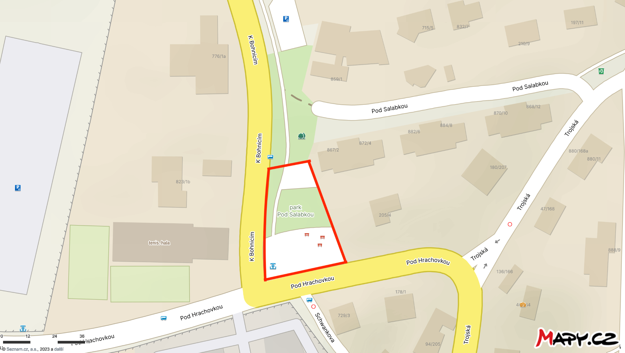

Photos:

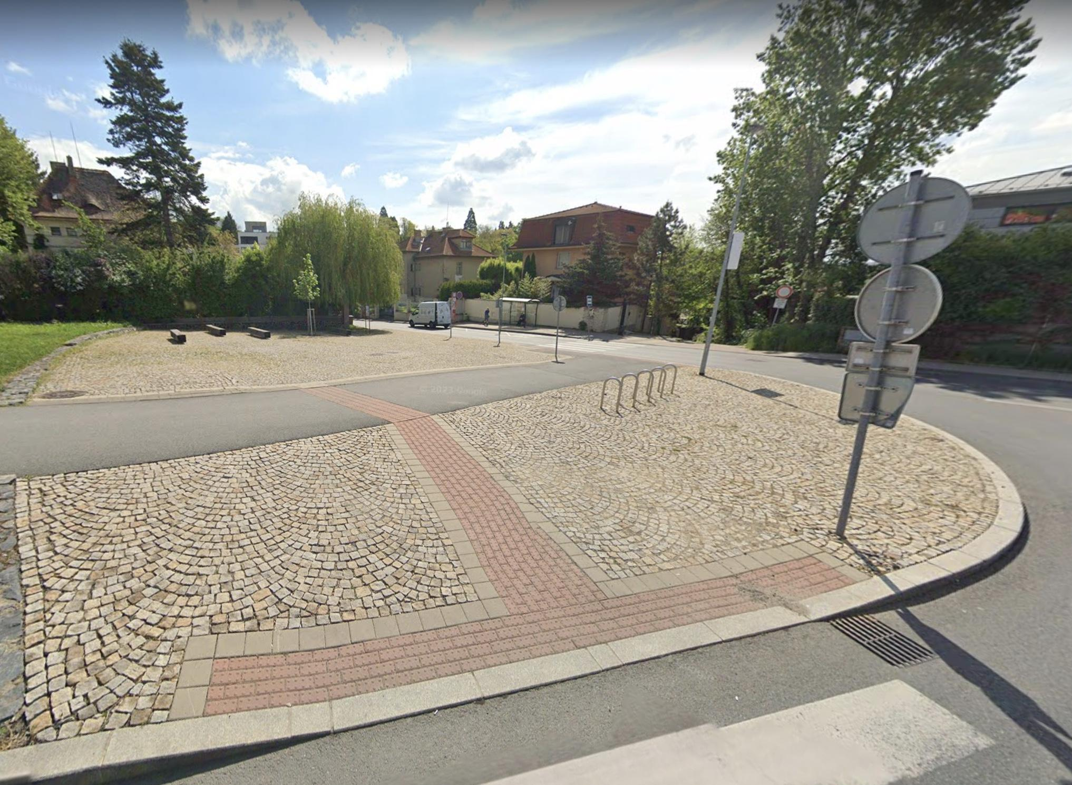
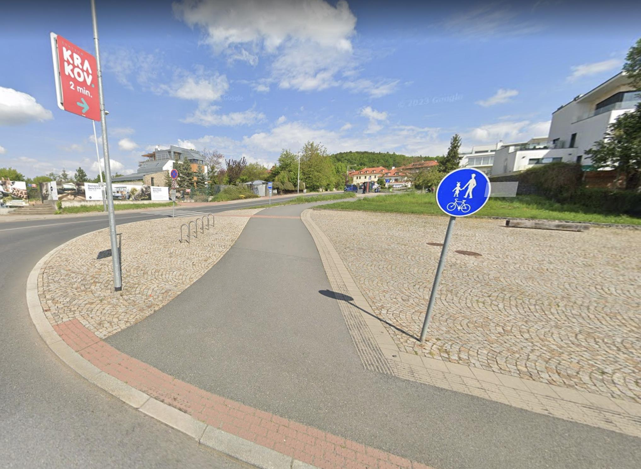
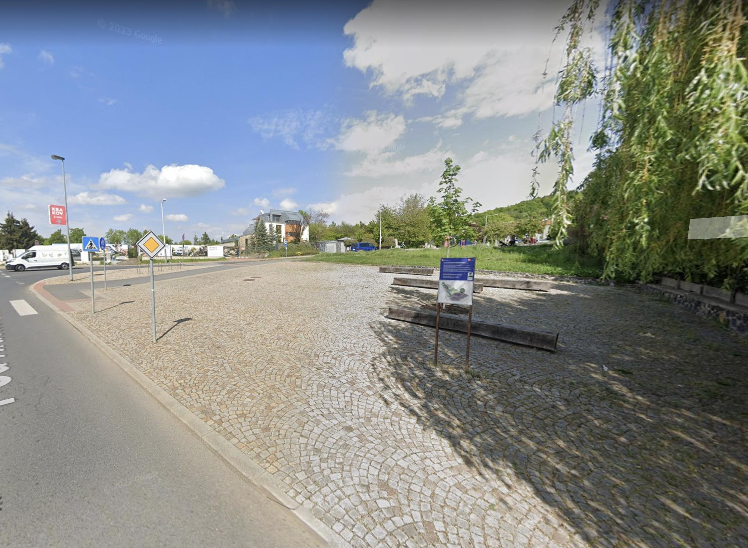

Vltava in Troja Basin

- Performances

  - Former ford
  - Watermill
  - Axis of the chateau, way of the bulwark
  - Rybáře Village

The Troja Basin was formed by the Vltava River over the millennia. The river used to part of the landscape, and the landscape was part of the river. By the landscape, we mean the river floodplain – a flat area made up of old alluvial deposits, covered with meadows, floodplain forests and pools, annually flooded with water. Cattle was grazing in the fertile floodplain, vegetables and fruit were grown. Nothing was built right on the riverside except the watermills. Houses were built on the edge of the floodplain, to be protected from floods. In this wide basin, the Royal Game Preserve was established; the Troja Chateau, the Imperial Mill and the Troja Mill were built at the foot of the slopes.
For a long time, the Troja Basin was considered “a countryside outside Prague”, with scattered houses, fruit orchards, and vineyards. Later, it became a popular go-to place for Prague citizens. Floods were a natural part of the area. It was the reason why the buildings were just scattered, and the natural qualities of the place have been preserved.
Since the beginning of the 19th century, the mutually equal coexistence with the river has changed and turned into a unilateral use of Vltava. The side branches were filled up, islands became parts of the mainland. The natural meanders were cut by the new navigation canal with uniform banks, and for decades the basin was dredged and regulated.
Today you can see Vltava bound up without its terraces; the river flows through the narrowest place in Prague here.

The former ford

The river is a barrier and an opportunity at the same time.
History and context:

For a long time, fords were the only place to get across the river, so they became sort of local hotspots. They enabled the settlement of Prague, but another ford was in the Troja Basin – next to the river crossing, it was also possible to build a chateau here.

It was always necessary to get across Vltava in Troja; in the late 19th century, no less than five ferries were operational here, used to transport milk, cheese, tomatoes, cauliflowers, cucumbers and cabbage. Since the ancient times, Troja was the popular destination for day trips, even before the establishment of the zoo. People were drawn here by the romantic nature and countryside vibes, with ferries and the scent of roast fish.

Until the footbridge was built in 1976, the ferry was the key means of transport connecting Troja to the city. When the water was low, the boats were connected into sort of a ponton bridge. The carts and then cars were transported across the river by a large ferryboat.

Among other things, the river was used to transport the loads on ships dragged by horses. For this purpose, the levees were built, and their remains can be still seen on the banks of Vltava.

Recommended form of realization:
Performance or art-research intervention
Map:

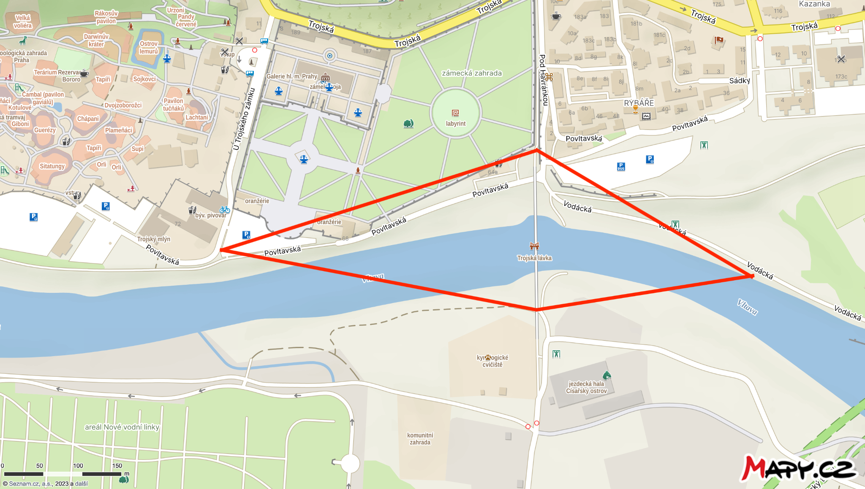
Photos:
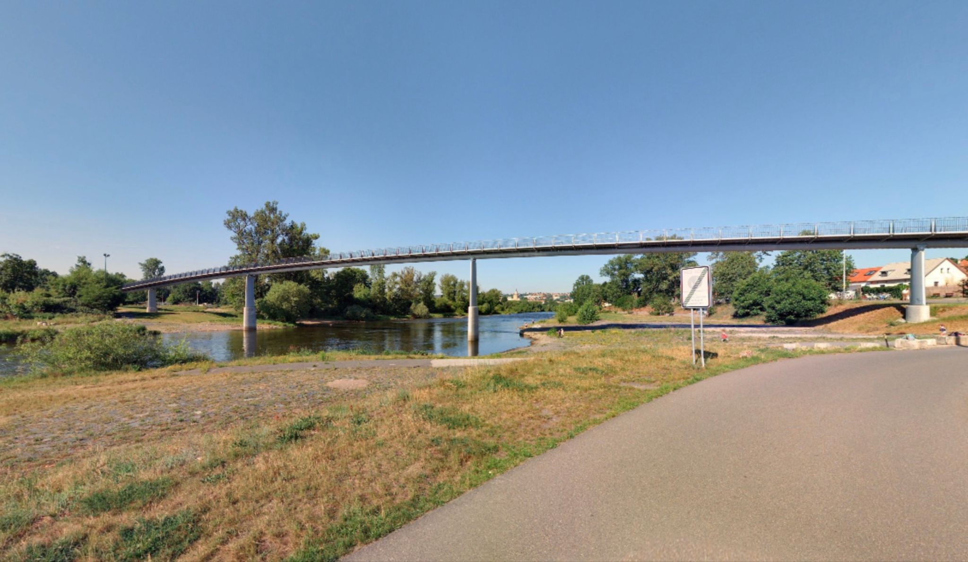
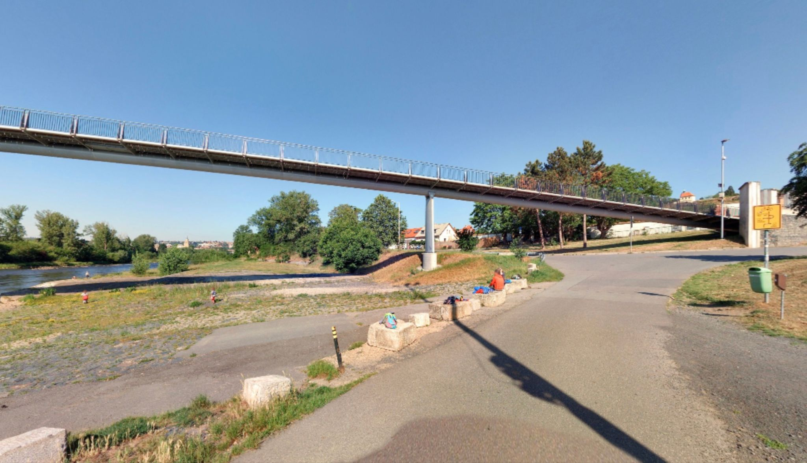
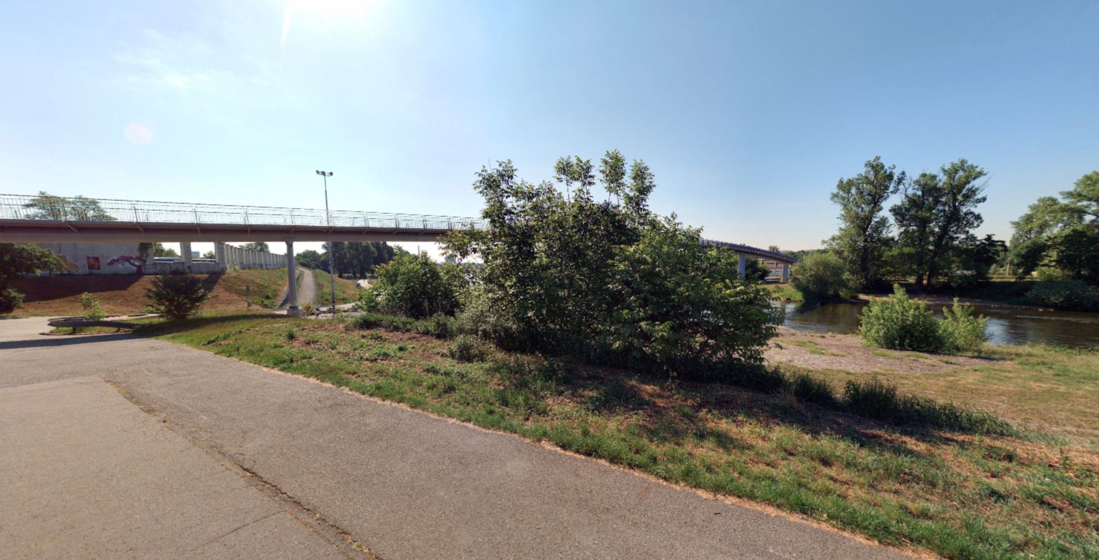

Watermill

The use of the river has changed significantly
History and context:

Historically, the surroundings of the river were used as a manufacturing and supply outskirts of the city. Today, the area is considered one of the most valuable recreational places.

The spontaneous formation and disappearance of gravel islands during floods have always encouraged human interventions. Dams and weirs were built, banks and islands reinforced. Two mills worked on either bank of the river: the one on the right bank was called the Troja Mill, while the Imperial Mill stood on the left bank.

Thanks to the adjacent Royal Game Reserve, the area has retained its character of floodplain meadows and groves. At the turn of the 20th century, the branch separating the Holešovice Island was filled in to make the river accessible for bigger ships, so the Imperial Island is the only one that has remained to this day.

Watermills were the only buildings standing right in the floodplain until the modern times. Then, the floodplain became home for the houses of poor fishermen who had to adapt their homes for regular floods.

Both mills in the Troja Basin were standing on the level of the lower edge of the Troja cataract, where the riverbed with the weirs was the steepest. The river was also used by the gem cutting factory built in the part of the Imperial Mill under Rudolf II, and later, in the 19th century, by a textile factory and the first mechanized paper mill.

Recommended form of realization:
Performance or art-research intervention
Map:

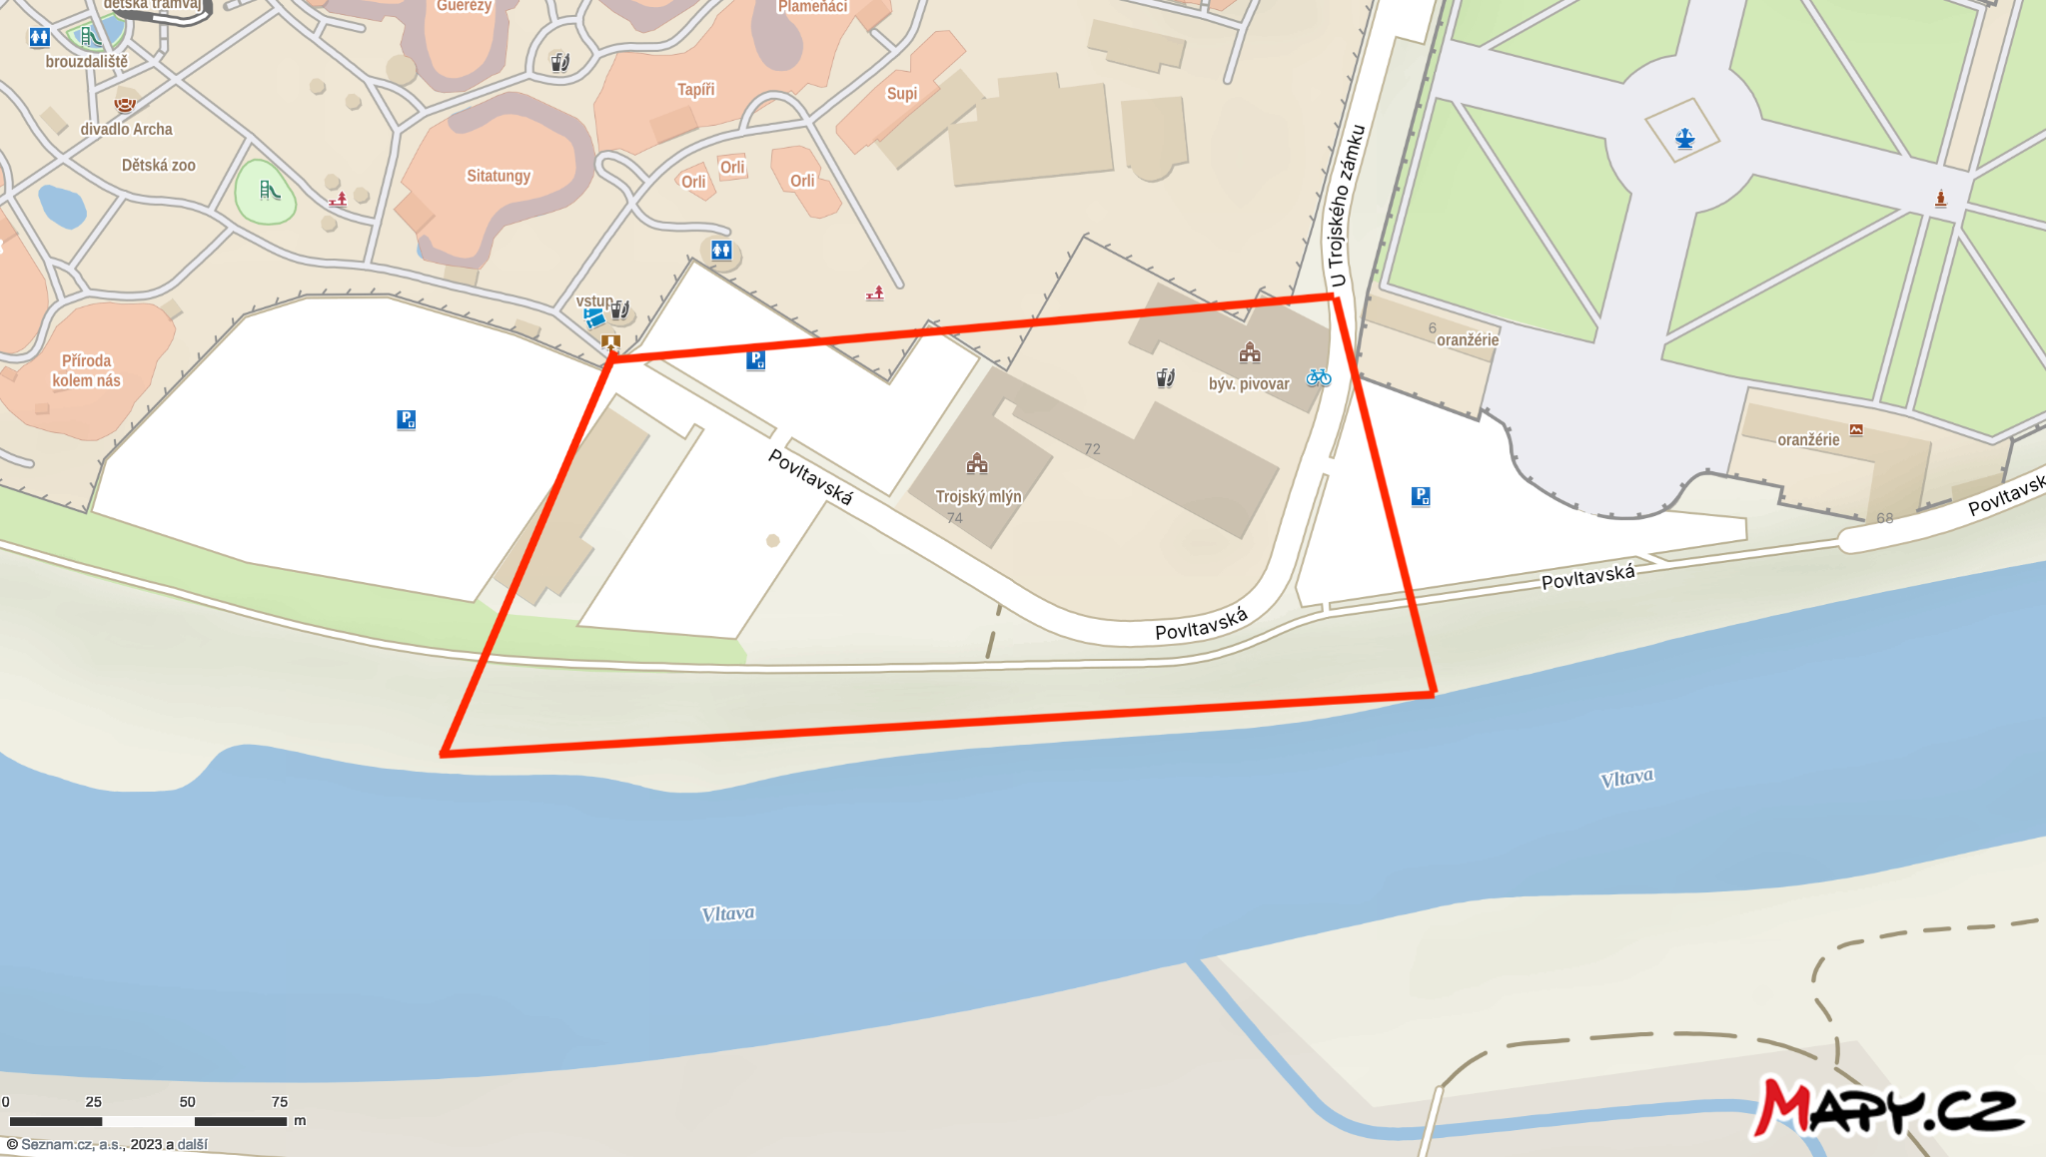

Photos:

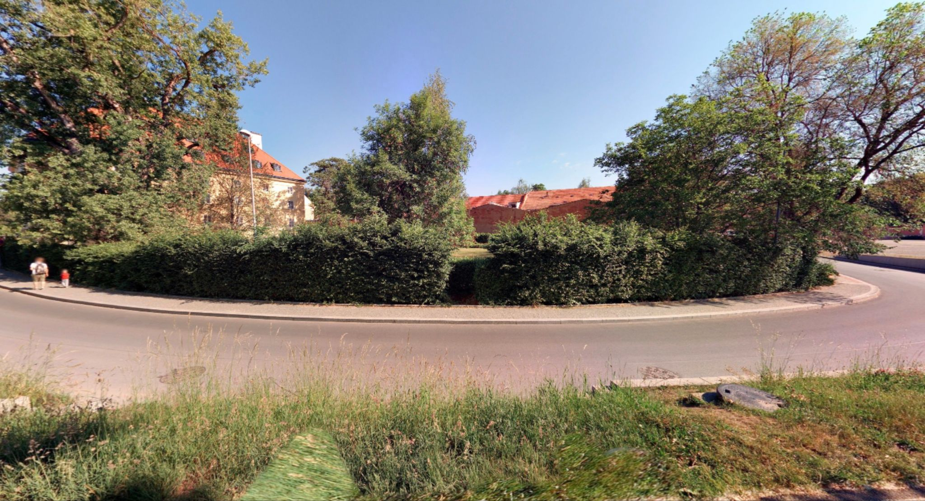
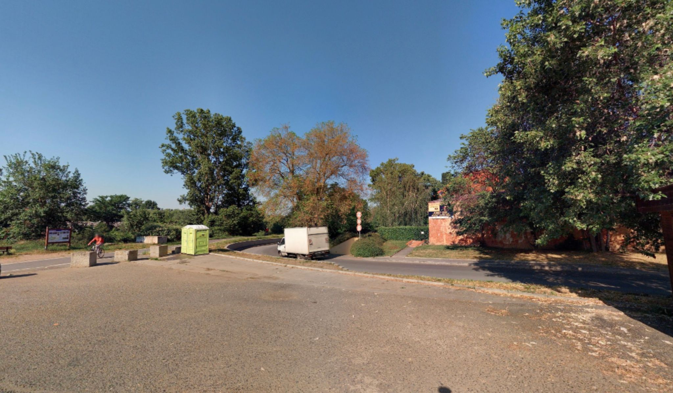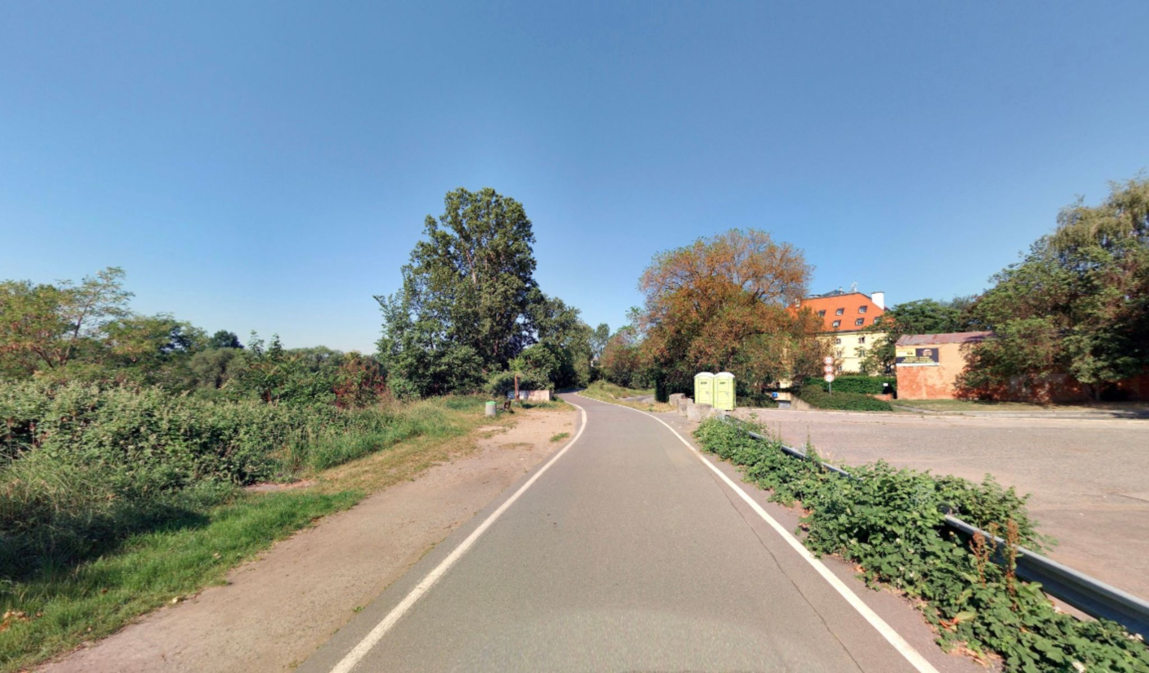

Axis of the chateau, way of the bulwark?

The broken connection

History and context:

At first, the chateau was directly connected to the riverbanks, with the axis aimed right at the Prague Castle. Today, this natural relationship is disrupted by the terrain adjustments, the bike track on the embankment, and the huge asphalt area of the former parking lot. The prevailing movement of people in the area has turned by 90 degrees. We're looking for new ways to reestablish this connection.

The Troja Chateau was built in the end of the 17th century as a suburban villa of Count Wenzel Adalbert von Sternberg. Architect Jean Baptiste Mathey cleverly projected the buildings on the very edge of the floodplain, so only the garden interfered with it. A ferry was built in the place of the ford ; from there, the guests entered the amazing park of flowers and sculptures through the gate near the river. The axis of the chateau and the garden aimed right at the Prague Castle.

The chateau is built on the terrace, partly artificial, that protects the building from floods.

Most of the nature around the river consists of plants caught on the riverbank accidentally, so they created an irregular composition without any rules and with only scarce human interventions. Therefore, a wild jungle has developed inside the city. The chateau garden, just a few steps away, is an exact opposite. The greenery here is tamed, maintaining accurate lines and adhering to the rules of French baroque gardens.

The opposite direction leads us across the bulwark to the Troja footbridge and the tram stop. Most people using public transport to visit the chateau or zoo takes the bus, never realizing that it’s a really nice walk along the bulwark. Our artistic interventions should emphasize this possibility, connecting the transport hub with the Troja Chateau.

Recommended form of realization:
Performance or art-research intervention
Map:

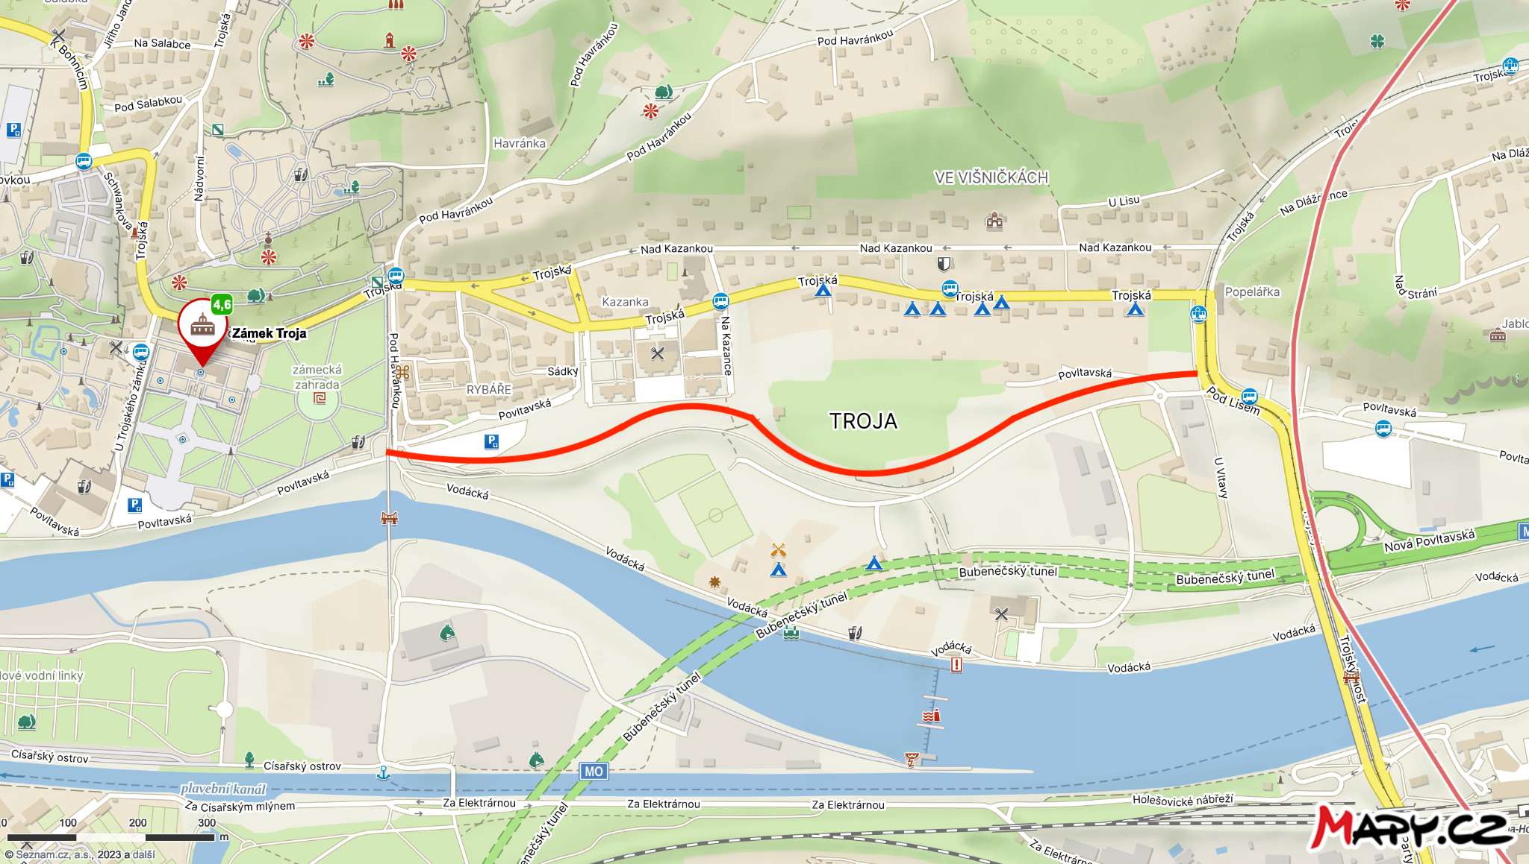

Rybáře Village
Living in harmony with the elements, or in spite of them

History and context:
The fishermen built their village so their living quarters were on the first floor to be protected against floods; the ground floors were only used for technical and sanitary facilities. Today, the Rybáře Village (Rybáře is Czech for fishermen) is separated from the river by a flood wall, 5 m high.
That said, floors have always been part of ordinary life in the Troja Basin. Old houses were adopted to it, with workshops or stores on the ground floor, and living quarters upstairs.

Modern flood protection adjustments also affected the location near the Troja footbridge.
The footbridge, now the second one, replaced the historic ferry with a ferryman’s cabin, used to transport thousands of Prague citizens from the Stromovka Park over the island on to Troja.

Recommended form of realization:
Performance or art-research intervention
Map:
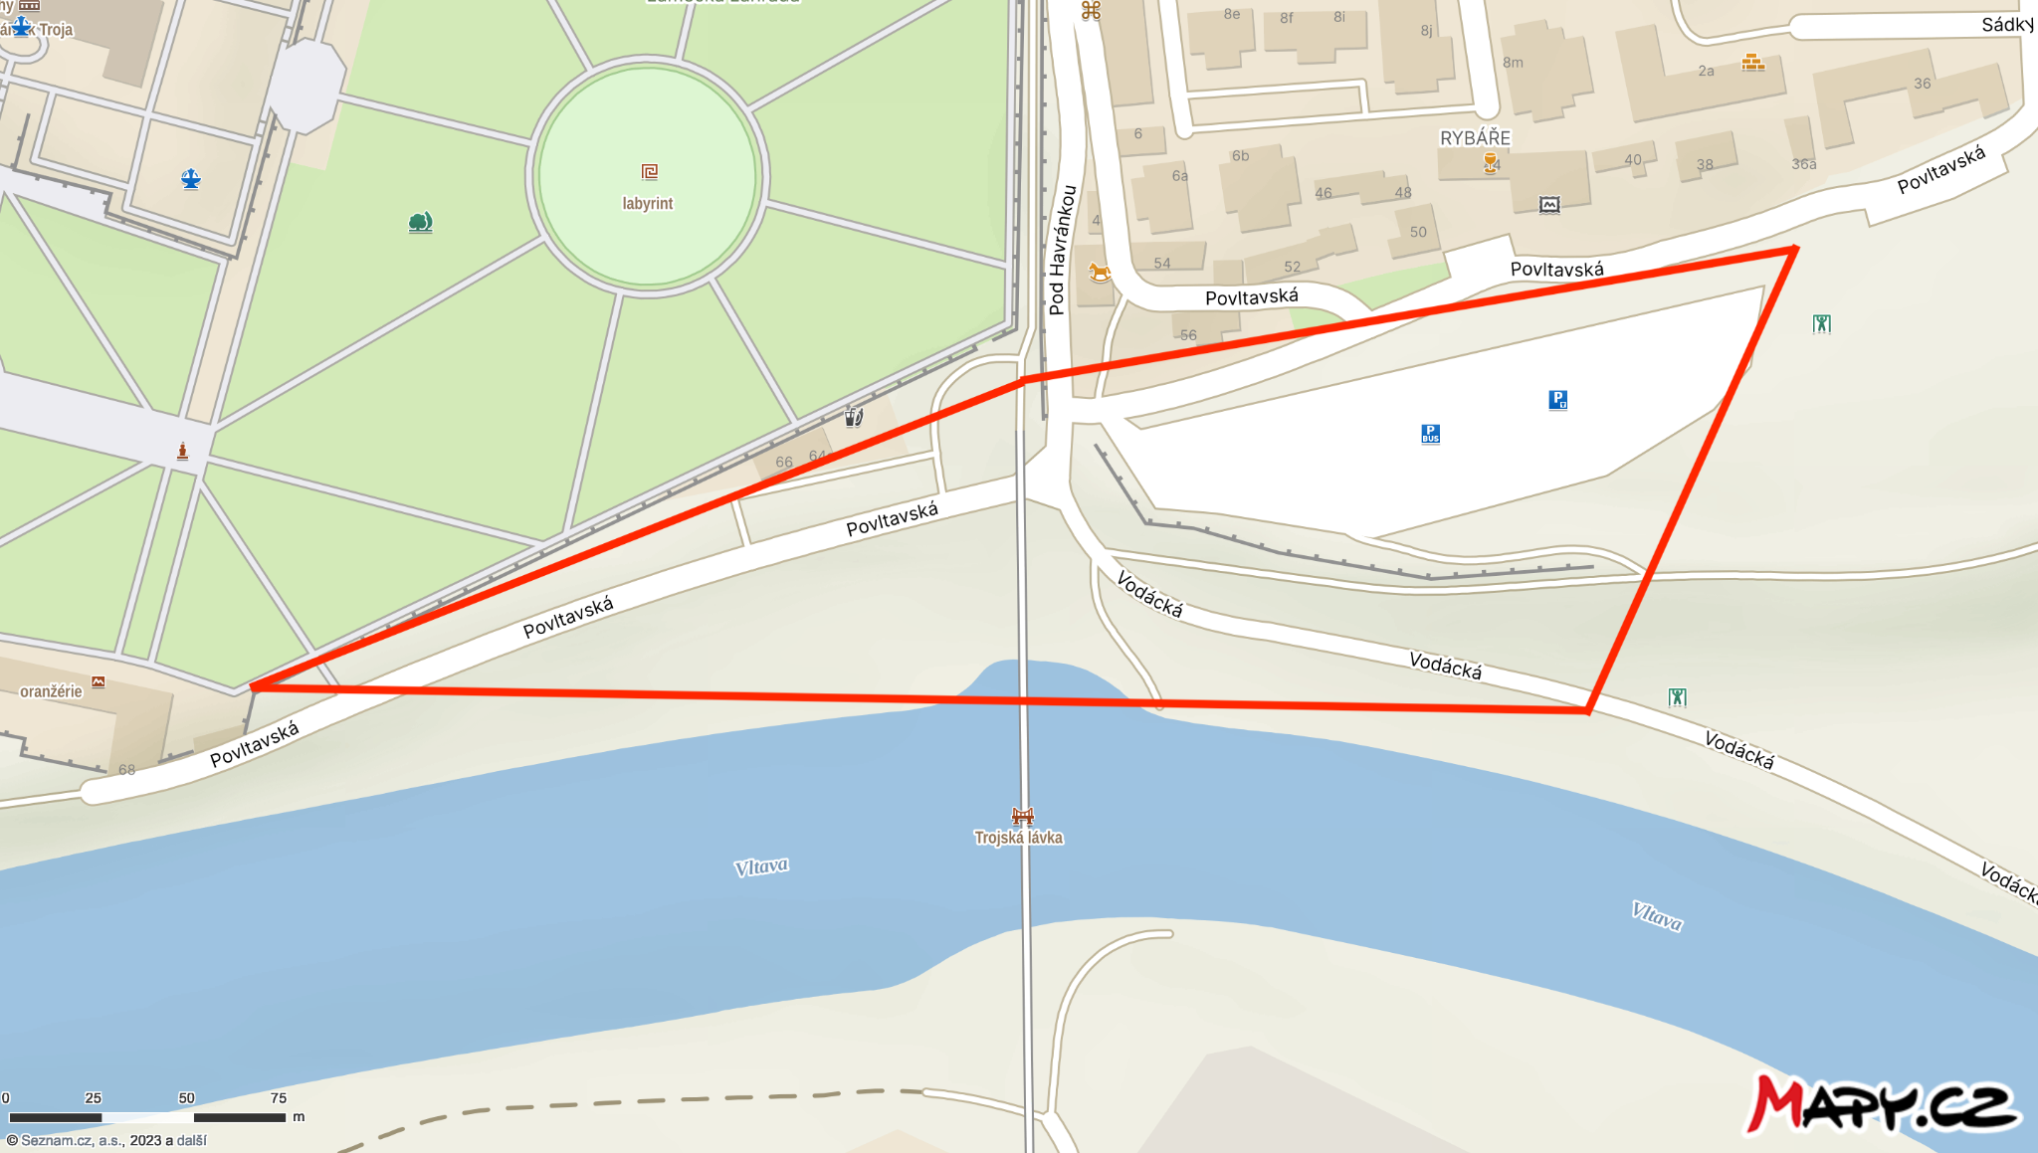

Photos:

